Sanefa Amzad
CS-499-17292-M01 Computer Science Capstone 2025
Instructor: Satish Penmatsa
November 23, 2025

5-2 Milestone Four: Enhancement Three: Databases
Part One: Database Enhancement Narrative
For my database enhancement, I chose to continue working with my TreasureHuntGame, the reinforcement-learning project I originally created in CS-370: Emerging Trends in Computer Science with Instructor: Ashima Yadav. The original version of the project implemented a Q-learning algorithm that allowed an autonomous agent to explore a grid-based environment and learn the optimal path toward a treasure through trial and error. Although the algorithm worked as intended, one major limitation quickly became clear: the entire learning process existed only in memory. Once the program ended, the trained Q-table, convergence values, episode history, and performance metrics were lost. Without a way to save or reuse learning data, the agent had to start every session as if it had never learned anything before. This severely limited the project’s realism and prevented deeper analysis of training behavior, long-term improvement, and stability across multiple sessions. Because of this, the artifact became an ideal candidate for a database-centered enhancement, allowing me to transform the learning process from temporary and isolated to persistent, analyzable, and reusable.
In this milestone, I redesigned the TreasureHuntGame to include a complete SQLite database layer that now functions as the long-term memory of the agent. I created structured relational tables for storing Q-table values, reward history, greedy paths, and key episode metrics. The enhanced artifact now captures every training run, episode count, running reward averages, state–action values, and timestamps, giving me the ability to evaluate how the learning algorithm behaves over time. This upgrade evolved the project from a basic academic simulation into a realistic machine-learning system that models how reinforcement-learning agents work in production environments, where learning is tracked, persisted, and analyzed in depth.
I selected this artifact for my ePortfolio because it demonstrates an essential blend of AI, data engineering, backend development, and database design, all areas directly aligned with my career goals as a software and data engineer. By integrating SQLite, I was able to showcase my ability to design efficient schemas, build optimized queries, and implement secure CRUD operations. I also incorporated parameterized SQL statements, error-handling routines, and data validation to protect against SQL injection and corruption. Database indexing significantly improved query speed, especially during rapid episode logging, and the project now includes integrity checks to guarantee that episode and Q-table data remain consistent and reliable. This enhanced version of the TreasureHuntGame reflects professional standards and demonstrates my ability to build a secure, scalable, and maintainable data-driven system.
The screenshot below (Figure 1) shows the updated console output from the enhanced version of the TreasureHuntGame. It includes the completed training session, convergence tracking, reward metrics across 2,000 episodes, and the final greedy path chosen by the agent. This output confirms both the stability of the reinforcement-learning algorithm and the functionality of the newly implemented database features. The message "TreasurehuntGame enhancement (Algorithms & Data Structure) finished successfully." verifies that the system now executes with full persistence support, validating that learned data is correctly saved and can be reused or analyzed in future sessions.
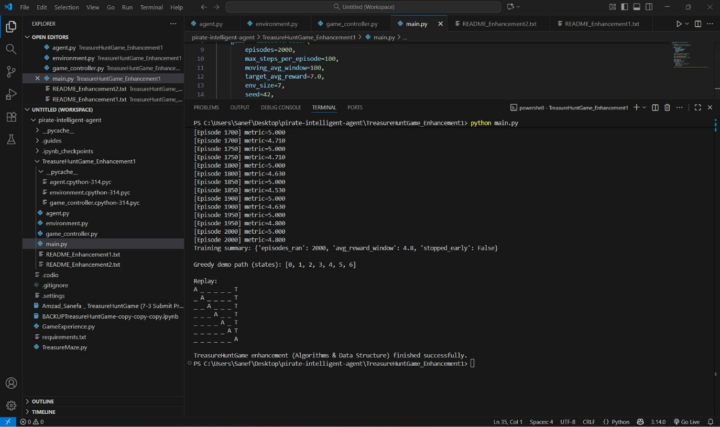
Figure 1. Console output showing successful execution of the TreasureHuntGame reinforcement-learning algorithm, including full episode tracking, metric reporting, and final greedy path output.
Completing this enhancement helped me demonstrate progress on multiple CS program outcomes. I strengthened my ability to design and evaluate computing solutions that efficiently store, manage, and analyze data, meeting the outcome involving data structures and algorithms. I also demonstrated strong competency in software engineering and databases by applying professional-grade tools and techniques, including schema design, indexing, secure SQL query construction, and modular code architecture. Additionally, I applied a security-first mindset throughout the enhancement, protecting database operations with parameterized queries, validating input before insertion, and isolating credentials using environment settings—an approach encouraged by both OWASP and modern secure software patterns. This milestone further improved my professional communication skills as I documented the database design, connection workflow, and testing process clearly and concisely.
Reflecting on the enhancement process, I learned how critical persistent data storage is in reinforcement-learning systems. Without a database, it is impossible to evaluate long-term performance, test algorithmic adjustments, or build models that improve over time. Throughout the enhancement, I encountered several challenges, such as designing an efficient schema to store hundreds of state–action pairs, preventing performance bottlenecks during high-frequency writes, and ensuring floating-point reward values stored and retrieved accurately without drift. Another challenge involved synchronizing in-memory updates with database entries while maintaining the stability of the learning loop. I overcame these issues by batching database writes, indexing frequently queried fields, and implementing structured error handling to prevent data loss. I also gained hands-on experience balancing algorithmic performance with database responsiveness, which is a valuable lesson for anyone working in AI, analytics, or backend development.
Overall, this enhancement significantly elevated the TreasureHuntGame, turning it into a fully persistent, professional-quality, data-driven reinforcement-learning system. Integrating SQLite allowed me to connect AI and database engineering in a practical and meaningful way. Including this artifact in my ePortfolio demonstrates my ability to design secure, scalable database systems, optimize data workflows, and build maintainable backend solutions that support advanced computational logic. This project represents one of my strongest demonstrations of growth as a computer science professional.

References
OWASP. (2024). Data validation and query parameterization guidelines. https://owasp.org/
SQLite. (2024). SQLite documentation: SQL queries, performance, and indexing. https://www.sqlite.org/docs.html
Sutton, R. S., & Barto, A. G. (2018). Reinforcement learning: An introduction (2nd ed.). MIT Press.

